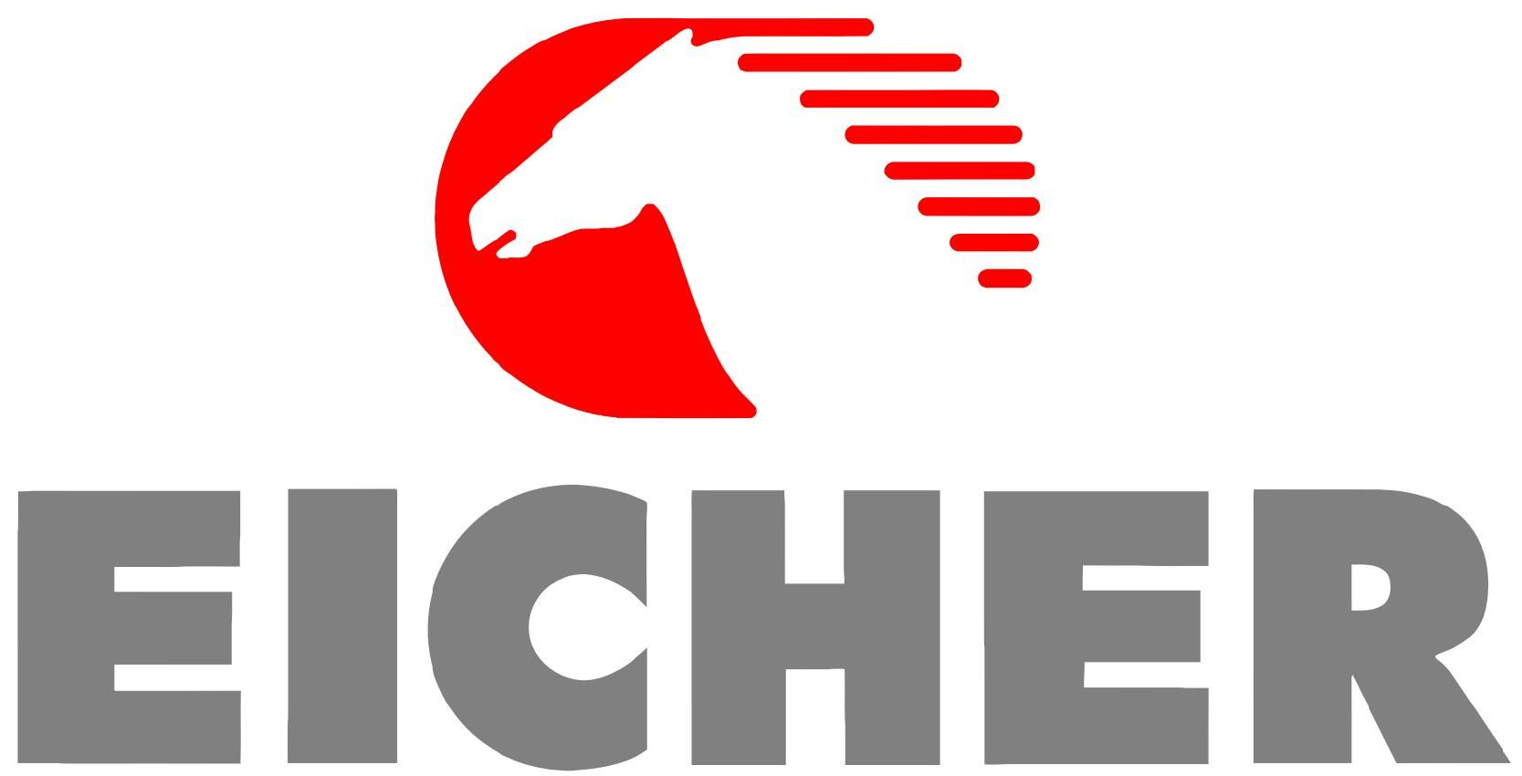

Group No: 11

Company: Eicher Motors

**Submitted By:**

Graisy Biswal 20020845007

Anoushka Viegas 20020845027

Sandeep Ravindra Taksande 20020845030

# Question No. 1

# Calculate the financial distress of the company using Z-score model, show all calculations on word file and interpret the results in your own word.

# Solution

Z score is calculated using the following ratios:

1. X1 (Working Capital/ Total Assets)
2. X2 (Retained Earnings/ Total Assets)
3. X3 (EBIT (Earnings before Interest and Tax)/ Total Asset)
4. X4 (Market Value of Equity/ Total Liabilities)
5. X5 (Net Sales/ Total Assets)

On calculating these values for Eicher Motors:

|  |  |  |  |  |  |
| --- | --- | --- | --- | --- | --- |
| X1 |  | 4475.48 |  | 0.4230528187420 | This ratio is considered to be a good test for corporate distress. Here the ratio is positive which implies Eicher do not have any trouble paying its’s bills. |
|  |  | 10579.01 |  |
| X2 |  | 7,663.16 |  | 0.72437401988 | This ratio measures the amount of reinvested earnings or losses, which reflects the extent of the company's leverage. Eicher is considered to be having a high RE/TA which suggests that is has a history of profitability and has the ability to stand up to a bad year of losses. |
|  |  | 10579.01 |  |
| X3 |  | 1825.86 |  | 0.172592709526 | The ratio of EBIT and Total Assets is a version of Return of Assets which is an effective way of assessing a company's ability to squeeze profits from its assets before deducting factors like interest and tax. Eicher is slightly in a better position to squeeze profits before deducting interest and tax. |
|  |  | 10579.01 |  |
| X4 |  | 3575.78 |  | 1.55221016899 | This ratio shows that if a firm were to become insolvent, how much the company's markets values would decline before liabilities exceed assets on the financial statement. Here, Eicher’s is in a better position which implies is has a solid financial position. |
|  |  | 2303.67 |  |
| X5 |  | 9008.69 |  | 0.85156266985 | This ratio tells investors how will management handles competition and how efficiently the firm uses assets to generate sales. The ratio value 0.8515 signifies that Eicher the management is not too well in handling the competition and not so efficient in handling its assets to generate sales, but still in a manageable position. |
|  |  | 10579.01 |  |

Using the formula we get:

|  |  |
| --- | --- |
| FORMULA | |
|  |  |
| Z (1968 Version) | 0.72X1+0.85X2+3.1X3+0.42X4+X5 |
|  | 2.958844287 |
| Altman | 3.25+6.56X1+3.26X2+6.72X3+1.05X4 |
|  | 8.72013959 |
| Altman For Emerging Markets | 6.56X1+3.26X2+6.72X3+1.05X4 |
|  | 5.47013959 |

From since a Z score is 2.9 represents a company with a safe balance sheet and from calculations the of Eicher Motors Ltd is 2.958844287, it can be clearly observed that the company is in the "SAFE" zone.

**Question No. 2**

# Using the Dupont analysis method, calculate the ROE of the company and show all calculations. Interpret the results by taking the same ratios of any two other companies from the same sector.

# Solution

# 

* According to the Dupont Analysis Method, ROE is calculated from the product of 3 ratios and it is used to exhibit how efficiently a company has used the money invested by shareholder.
* The three ratios used in this method are
  + Net profit margin (Net profit /total revenues) - This is kept high by maintaining and growing healthy profit margins by reducing expenses
  + Asset turnover (Sales/Total Average Assets) - Computes the efficiency of the company in using its assets.
  + Equity multiplier (Total Average Assets/Average Shareholders Equity) - Analyses the portion of the ROE from debt.

|  |  |  |  |
| --- | --- | --- | --- |
|  | Eicher Motors Ltd. | Ashok Leyland Ltd. | Force Motors Ltd. |
| Total capital and liabilities 2019 | 9,477.41 | 18,224.40 | 2,835.90 |
| Total capital and liabilities 2020 | 10,579.01 | 16,389.61 | 3,106.54 |
| Average Total Assets | 10028.21 | 17307.005 | 2,971.22 |
| Total Share Holders Fund 2019 | 7,126.45 | 8,332.43 | 1,934.87 |
| Total Share Holders Fund 2020 | 8,275.34 | 7,263.99 | 1,975.71 |
| Average Shareholders' Equity | 7700.895 | 7798.21 | 1955.29 |

|  |  |  |  |
| --- | --- | --- | --- |
|  | Eicher Motors Ltd. | Ashok Leyland Ltd. | Force Motors Ltd. |
| Net Income | 1827.44 | 456 | 179 |
| Revenue | 9696.83 | 22,059 | 3,122.90 |
| Sales | 9008.69 | 17467.47 | 3,053.08 |
| Average Total Assets | 10579.01 | 17307.005 | 2971.22 |
| Average Total Assets | 10579.01 | 17307.005 | 2971.22 |
| Average Shareholders' Equity | 8275.34 | 7798.21 | 1955.29 |

* Comparing the Three ratios from the Eicher Motors Ltd.,  Ashok Leyland Ltd. and Force Motors Ltd
* Net profit margin (Net profit /total revenues) -
  + Net profit Margin for Eicher Motors Ltd. is the highest (Force Motors comes second and Ashok Leyland Third).
  + This shows that Eicher Motors Ltd.  is able to generate higher sales while maintaining a lower cost of goods
* Asset turnover (Sales/Total Average Assets) - Computes the efficiency of the company in using its assets.
  + Asset turnover ratio is the lowest for Eicher Motors Ltd (by a small margin)
  + The Other 2 companies are selling their  products at a lower margin but have higher asset turnover ratios indicating that these companies are utilising assets effectively to generate more sales.
* Equity multiplier (Total Average Assets/Average Shareholders Equity) - Analyses the portion of the ROE from debt.
  + The equity multiplier is a tool to analyse what portion of the ROE is a result of debt.
  + Ashok Leyland Ltd has the highest equity multiplier ratio and Eicher motors has the lowest
  + This shows that Eicher Motors is not using its debt to push up its ROE which can be bad for the health of the company.
  + Eicher Motors Ltd  is less risky as its financial leverage is very low.

|  |  |  |  |
| --- | --- | --- | --- |
|  | Eicher Motors Ltd. | Ashok Leyland Ltd. | Force Motors Ltd. |
| ROE % | 20.51583234 | 4.630353006 | 8.949977807 |
| ROE | 0.205158323 | 0.04630353 | 0.089499778 |

* Comparing ROE % of all three companies; Eicher Motors Ltd.,  Ashok Leyland Ltd. and Force Motors Ltd
  + Eicher Motors Ltd has the highest ROE at 20.51%
  + This shows that it has used shareholders’ money efficiently.
  + Since it’s ROE is above 20% it can be considered to be a good investment in this sector
  + Also since it has a relatively low Equity multiplier, we know that it is not using an excess of debt to push up its ROE, and so it is a good investment for a long time

**Queston No. 3**

**Taking three scenarios (boom, recession, and normal) forecast the financial distress, or probability of the bankruptcy. Forecast the sales and then based on sales forecast the rest of the items of P&L and Balance Sheet and calculate the forecasted ratios used in Z score and calculate the Z score for next two years.**

**Solution**

**Under NORMAL condition**

|  |  |  |  |
| --- | --- | --- | --- |
| YEAR | 2020 | 2021 | 2022 |
| Z Scores | 2.958844138 | 2.993258681 | 3.0039322 |

**Inference:**

The Z-score of Eicher for the year 2020 is 2.958844 which implies that the company is in the safe zone. Forecasting for the years 2021 and 2022 under NORMAL conditions, the Z-score calculated is 2.9932 and 3.0004 respectively which is greater than 2.90. Hence it can be inferred that under NORMAL conditions, Eicher will remain in the safe zone

**Under BOOM Condition**

|  |  |  |  |
| --- | --- | --- | --- |
| YEAR | 2020 | 2021 | 2022 |
| Z Scores | 2.958844138 | 3.0067181 | 3.0319612 |

**Inference:**

The Z-score of Eicher for the year 2020 is 2.958844 which implies that the company is in the safe zone. Forecasting for the years 2021 and 2022 under BOOM conditions, the Z-score calculated is 3.0067 and 3.0319 respectively which is greater than 2.90. Hence it can be inferred that under BOOM conditions, Eicher will remain in the safe zone

**Under RECESSION Condition**

|  |  |  |  |
| --- | --- | --- | --- |
| YEAR | 2020 | 2021 | 2022 |
| Z Scores | 2.958844138 | 2.9628513 | 2.9483655 |

**Inference:**

The Z-score of Eicher for the year 2020 is 2.958844 which implies that the company is in the safe zone. Forecasting for the years 2021 and 2022 under RECESSION conditions, the Z-score calculated is 2.9628 and 2.9483 respectively which is greater than 2.90. Hence it can be inferred that under RECESSION conditions, Eicher will remain in the safe zone.

# Working of Assignment:

# 